ALLAMA IQBAL OPEN UNIVERSITY, ISLAMABAD
(Department of Islamic Thought, History and Culture)
Warning
- Plagiarism or hiring of ghost writer(s) for solving the assignment(s) will debar the student from award of degree/certificate, if found at any stage.
- Submitting assignment(s) borrowed or stolen from other(s) as one’s own, will be penalized as defined in “AIOU Plagiarism Policy”.

Course: Political System of Islam (1907) Semester: Autumn, 2026
Level: BS (Islamic Studies, English Version)

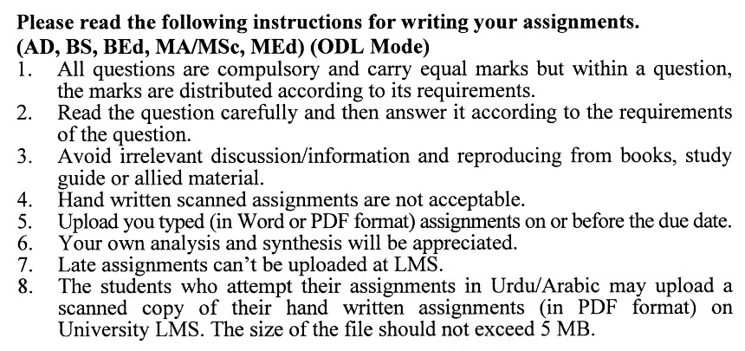

Total Marks: 100 Pass Marks: 50

Assignment No. 1
(Units: 1-04)

Q.1 State the details of Secularism. (20)
Q.2 Describe the details of Liberalism. (20)
Q.3 Write about Democracy. (20)
Q.4 Write about Modernism. (20)
Q.5 Describe Postmodernism. (20)

Total Marks: 100 Pass Marks: 50

Assignment No. 2
(Units: 5-9)

Q.1 Describe the Prophet’s Teachings on Social Justice. (20)
Q.2 Describe the Rights of the Poor in Islam. (20)
Q.3 Describe the Rights of Orphans in Islam. (20)
Q.4 Describe the Rights of Women in Islam. (20)
Q.5 Describe Social Justice and Environmental Stewardship in Islam. (20)

